**Experiment No. 2.0**

**Student Name:** Gaurav Kumar **UID:** 22MCC20177

**Branch:** MCA**–**CCD **Section/Group:** MCD-1/A

**Semester:** III **Date of Performance:** 15th Nov 23

**Subject Name:** Business Analytics **Subject Code:** 22CAH-703

1. **Aim/Overview of the practical:**
   1. Implementation of Dashboard in Tableau.
2. **Code for practical: (a)**

A **dashboard** is a collection of several views, letting you compare a variety of data simultaneously. For example, if you have a set of views that you review every day, you can create a dashboard that displays all the views at once, rather than navigate to separate worksheets. Millions of rows of data can be handled with efficiency via Tableau. Large amounts of data can be used to generate a variety of visualization without compromising the dashboards' performance. Additionally, Tableau has a feature that allows users to create “live” connection to other data sources, such as SQL, etc.

1. Create a new dashboard by clicking on the dashboard option from the task bar.

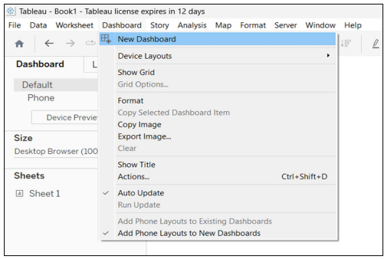

1. The dashboard will look like this.

1. Now, drop the sheets from the Sheets options on screen.

1. To create floating sheets, click on the arrow provided on the top right of the sheet and select the option as shown below.

1. The floating sheets will be created which will look like this in the dashboard.
2. You can resize these sheets according to your need to get a clear view of the data.